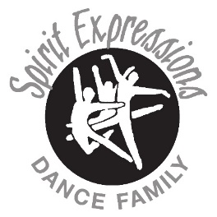
Spring/Summer Dance Opportunities
We hope you can join us for some of our spring/summer programs! Register online: www.spiritexpressions.biz If you have questions, email Miss Jen: jen@spiritexpressions.biz
Dance Camp – A variety of teachers and styles for our intermediate/advanced dancers
- Five days of exciting classes with guest teachers including tap, ballet, contemporary, musical theater, stretch and tone, hip hop, improvisation, modern, and more!
- Dancers must be 8 years or older and have at least 2 – 3 years of dance experience
- Cost: $200.00 includes all classes and a camp shirt. Cost is $195 if paid by May 1st.
- Informal show on Friday at 2:15 p.m. where dancers will perform the routines they’ve learned during the week – Dancers should wear black bottoms (shorts, skort, capris, dance pants) and their camp shirt. Bring your camera!
- June 10 - 14, 2024 at the studio from 9:00 a.m. – 3:00 p.m. each day (lunch break from 12 – 1 p.m. each day)
- Must be registered with tuition paid by May 24th to guarantee a camp shirt
Jr. Dance Camp – Taught by Miss Jenna, Miss Maggie, Miss Emma, and Miss Jen
- Four half-days of exciting classes including tap, ballet, hip hop, jazz, improvisation, stretching, crafts, and more!
- Dancers must be 5 - 8 years of age (by December 31, 2024), no experience necessary
- Cost: $150.00 includes a camp shirt and all craft supplies. Cost is $145 if paid by May 1st.
- Informal show on Friday at 11:30 a.m. where dancers will perform the routines they’ve learned during the week – Dancers should wear black bottoms (shorts, skort, capris, dance pants) and their camp shirt. Bring your camera!
- June 18 - 21, 2024 at the studio from 9:00 a.m. – 12:00 p.m. each day (Tuesday – Friday)
- Must be registered with tuition paid by May 24th to guarantee a camp shirt
Cuddly Animals Dance Days – Taught by Miss Emma and Miss Jen
- Three morning sessions of fun with an animal theme! We’ll learn some dances, do some crafts, and have lots of fun!
- Dancers must be 4 – 7 years old, no experience necessary
- Cost: $90.00 includes the classes for three days, a shirt, and all craft supplies. Cost is $85 if paid by May 1st.
- June 24 - 26, 2024 at the studio from 9:00 – 11:00 a.m. each day (Monday – Wednesday)
- Must be registered with tuition paid by May 24th to guarantee a shirt
Competition Team Q & A for parents and dancers – Monday, May 20th at 7:00 p.m. at the studio – If you are considering auditioning, please plan on being there. Parents and dancers who have been on the team before can help answer your questions, as well as some of the coaches. Our goal is to answer all of the questions you have so that you can be as prepared as possible for the audition and season.
Competition Team Auditions for the 24-25 Season – Wednesday, June 26th, Ages 7 – 11: 4:00 – 6:00 p.m., Ages 12 – 18: 6:30 – 8:30 p.m.
- Plan on being there the entire time for your age group. The room will open up 30 minutes before the audition begins so that you can stretch yourself out. We will not be leading a warm up.
- We’ll do a quick interview question, ballet, tap, jazz, and hip hop. Bring all of your dance shoes, including sneakers for hip hop.
Three Week Sessions – The last class will be visiting week.
Prices: 30-minute classes are $25, 45-minute classes are $35, 60-minute classes are $45, 90-minute classes are $60. This price covers all three weeks.
Three-week sessions: May 14 – 30, 2024

Tuesdays with Miss Hanna – May 14, 21, and 28 (Visiting Week is the last class.)
- Conditioning (for dancers in middle or high school who are interested in developing their strength, endurance, and flexibility) 4:30 – 5:00 p.m., $35
- Advanced Jazz Technique (for dancers in Jazz 4 – Senior Line) 5:00 – 6:00 p.m., $45
- Intermediate Jazz Technique (for dancers in Jazz 2-3) 6:00 – 7:00 p.m., $45

Tuesdays with Miss Makayla – May 14, 21, and 28 (Visiting Week is the last class.)
- Jr. Musical Theater (for dancers ages 6 – 11) 4:00 – 4:45 p.m., $35
- Sr. Musical Theater (for dancers ages 12 – 18) 4:45 – 5:30 p.m., $35
- Adult Musical Theater (for dancers ages 18 and up) 5:30 – 6:15 p.m., $35

Tuesdays with a variety of coaches – May 14, 21, and 28 (Visiting Week is the last class.)
- Competition Team Audition Prep – (for dancers considering auditioning for the 24-25 competition team, must be going into 2nd – 12th grade for 2024-25) 7 – 8:30 p.m., $60

Wednesdays with Miss Jenna - May 15, 22 and 29 (Visiting Week is the last class.)
- Intermediate Tumbling (for jazz/acro 1 or 2 levels, must be at least 6 years old) 4:30 – 5:30 p.m., $45
- Beginning Acrobatics (no experience necessary or intermediate acro level, must be at least 5 years old) 5:30 – 6:15 p.m., $35
- Advanced Tumbling (for jazz/acro 3 or 4 levels) 6:15 – 7:15 p.m., $45
- Advanced Tap (for levels 4, jr and sr lines) 7:15 – 8:00 p.m., $35
Wednesdays with Miss Jen – May 15, 22 and 29 (Visiting Week is the last class.)
- Intermediate Ballet Technique (for dancers in ballet 2 or 3) 4:00 – 5:00 p.m., $45
- Advanced Ballet Technique (for dancers in ballet 4, 5, or sr) 5:00 – 6:00 p.m., $45
- Baby Stars (for dancers ages 3-5, must be potty-trained, no experience necessary) 6:00 – 6:45 p.m., $35
- Senior Solo Prep (All 2025 seniors who are planning to perform a solo in the 2025 recital are required to take this class. We’ll talk about putting together a solo, costuming, senior deadlines and details.) 6:45 – 7:15 p.m., $25

Thursdays with Miss Maggie - May 16, 23 and 30 (Visiting Week is the last class.)
- Beginning Hip Hop (no experience necessary or hip hop 1 level, must be at least 6 years old) 4:00 – 4:45 p.m., $35
- Tap 1 (no experience necessary or tap 1 level, must be at least 5 years old) 4:45 – 5:30 p.m., $35
Thursdays with Miss Heather - May 16, 23 and 30 (Visiting Week is the last class.)
- Hip Hop Stalls and Tricks (for dancers ages 9 and up) 5:30 - 6:15 p.m., $35
- Intermediate/Advanced Hip Hop (for dancers in Hip Hop 2 – Sr) 6:15 – 7:00 p.m., $35
- Intermediate Tap (for levels 2 and 3) 7:00 – 7:45, $35

Thursdays with Miss Jen - May 16, 23 and 30 (Visiting Week is the last class.)
- Baby Stars (for dancers ages 3-5, must be potty-trained, no experience necessary) 4:45 – 5:30 p.m., $35
- Ballet 1 (no experience necessary or ballet 1 level, must be at least 5 years old) 5:30 – 6:15 p.m., $35
- Jazz 1 (no experience necessary or jazz 1 level, must be at least 5 years old) 6:15 – 7:00 p.m., $35
- Future Staff Member Training - If you are interested in being an assistant or a future dance teacher, come and learn what it takes. (Current assistants who are hoping to assist again are required to come to this class. Dancers must be going into 6th grade or older) 7:00 – 7:30 p.m. This class is free.

Spirit Expressions Dance Family
Audition for Class Levels
- We ask all dancers in our intermediate and advanced levels to audition for class levels. Please see the list below for specific classes that need to attend the audition.
- There is no charge for these auditions.
- This is a wonderful experience for your dancer to learn about the audition process. We do not move dancers based on their age. We place dancers based on their skills and work ethic.
- Dancers who do not attend the audition will be placed in the level they were in for the 23-24 season.
- Please come to the level you were in this year AS WELL AS the level you are hoping to be in for 24-25. For example, if you are in jazz 4 and are working to be in junior line jazz, come to both auditions. If you are in ballet 2 and are working to be in ballet 3, come to the audition for ballet 3.
- If you are in the senior level of a class, please come to that audition.
- We’ll send the results via email by June 7th so that you have them in order to register for fall classes.
Monday, June 3rd

All levels of Contemporary: 4:45 – 5:30 p.m.

Ballet 3 and 4: 6 - 7 p.m.
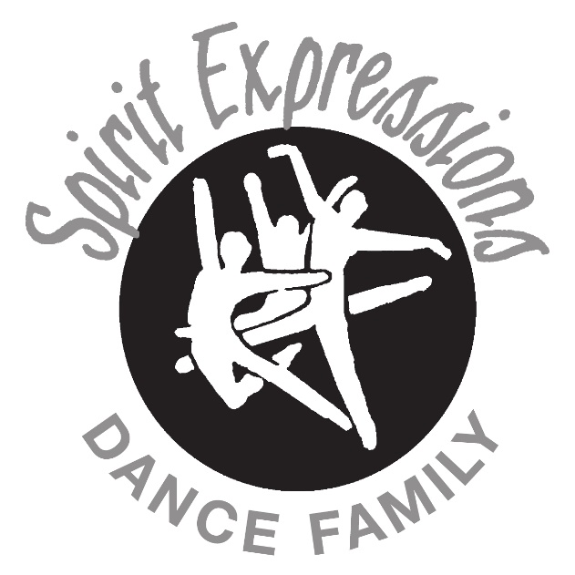
Ballet 5 and Sr. Ballet: 7 - 8 p.m.

Tuesday, June 4th

Hip Hop 2 and 3: 4 – 4:45 p.m.

Hip Hop 4 and Senior HH: 4:45 – 5:30 p.m.

Jazz 3 and 4: 6 - 7 p.m.

Jr. Line and Sr. Line Jazz: 7 - 8 p.m.

Wednesday, June 5th

Tap 3 and 4: 4 – 4:45 p.m.

Jr. Line and Sr. Line Tap: 4:45 – 5:30 p.m.

Jazz/Acro 1 and 2: 6 – 6:45 p.m.

Jazz/Acro 3 and 4: 6:45 – 7:30 p.m.

